**[Hex Gimp Technique - Elevation](https://www.thepiazza.org.uk/bb/viewtopic.php?p=288834" \l "p288834)**

* [**Quote**](https://www.thepiazza.org.uk/bb/posting.php?mode=quote&p=288834)

[Post](https://www.thepiazza.org.uk/bb/viewtopic.php?p=288834#p288834) by **[DJShade](https://www.thepiazza.org.uk/bb/memberlist.php?mode=viewprofile&u=370)** » Mon Aug 02, 2021 3:12 pm

Aloha folks - I was experimenting with brushes and paths this weekend and discovered a way to fairly reproduce Thorf's elevation within hexGimp. I had to make a new brush for this as well.

1. Download [https://drive.google.com/file/d/1-_P8u1 ... sp=sharing](https://drive.google.com/file/d/1-_P8u1LtWhb7bMY8onolyGerL_ggrylw/view?usp=sharing) for the brush for the vertical black line. I have the size set to 40 to match what a normal hex gimp size, and I have spacing set to 16 to properly space out the lines. You will want to install this into your brush directory (My path is C:\Program Files\GIMP 2\share\gimp\2.0\brushes ).
2. Create a path to outline the elevation you want to show. In this case I'm using the Atraughin Plateau.  
   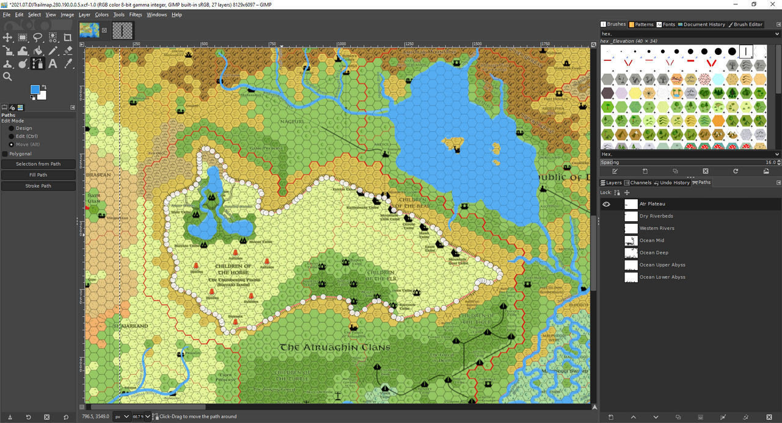
3. Next we will click "Path to Selection". This will select the inner part of the plateau. We need to then click "Select -> Invert". Once that is done you'll see the selection is from the outside of the path to the layer's border. I usually create a separate layer for elevations above the base terrain but below the water layer.
4. Click Stroke Path with the options "Stroke Line", "Solid Color" and a Line Width of 3. I choose line width of 3 as it helps outline better than choosing a line width of 2. A line width of 1 will miss some areas as the selection will cut some off depending on how the path is drawn by Gimp.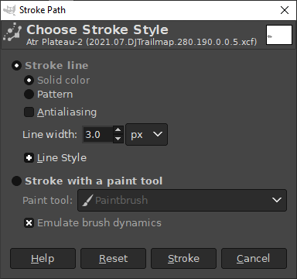
5. Select the Elevation Brush. Also select Dynamics - Track Direction.  
   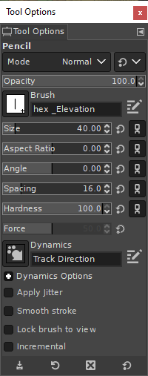
6. Finally select Stroke Path with the options "Stroke with a paint tool" Paintbrush. This will then draw the lines around the plateau.  
   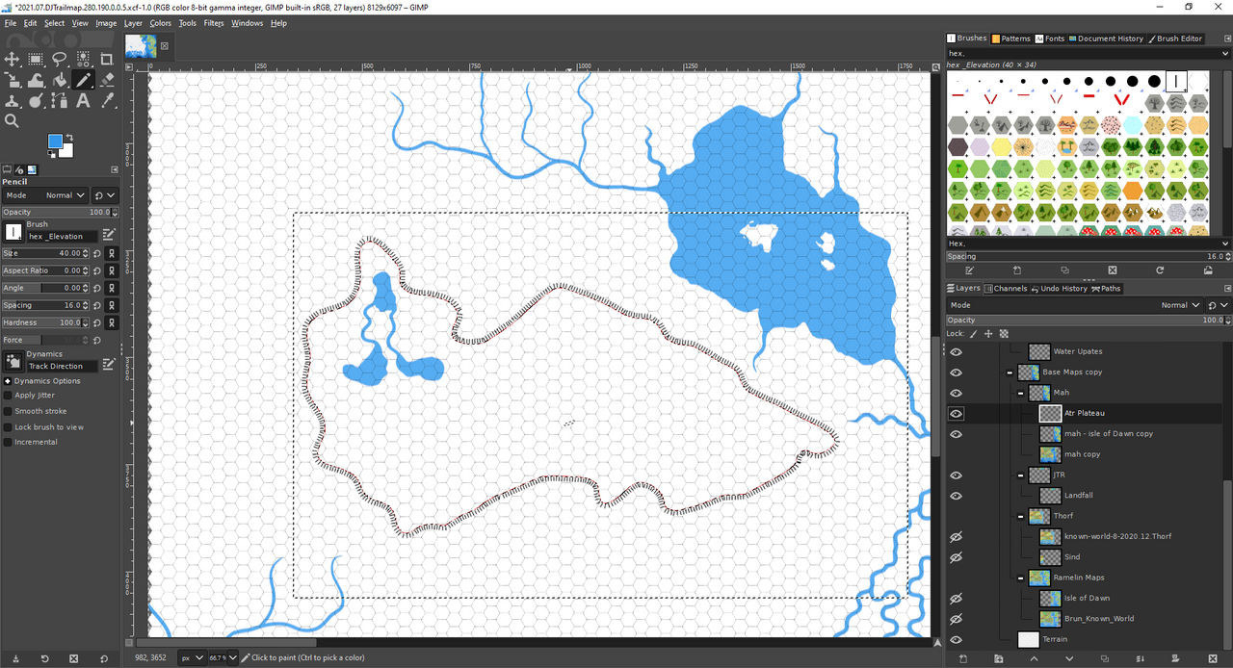

You may need to do some editing after it is drawn to remove a random pixel or two in the outline.  
  
I'm still doing some experiments on what works best for the different terrain types on each side of the elevation.  
Here is my current method I've been experimenting with.

1. First I draw out all the base terrain.
2. I then do a select of the path and cut and past that select block into a new layer.
3. I then delete all of the terrain within the selection on the initial layer.
4. I move the copied layer lower than the base terrain.
5. I then select all on the layer and delete the terrain.
6. I then add in terrain as normal. This gives the appearance of the terrain being different on each level.

I don't have images for it yet... but I'll try to add that in later.  
  
Let me know if folks have any suggestions on either process. Happy mapping :)